# Python Background

Python is both a general purpose programming language and a statistics programming language.

Its **general purpose** capability is equivalent to Java/C#, high-level programming with simple syntax, but lack of comparable efficiency as that of C++ (that is, Python/Java/C# programs would run a little bit slower than that of C/C++). Nowadays computation is cheap and this efficiency loss does not really matter for stats analysis.

Its **statistics** capability is mostly ported from Matlab and R. In terms of equivalence, most Matlab toolboxes have its python bothers (exclude Simulink). In terms of data limitation, it is equivalent to the most expensive version of Stata MP, that the amount of data is only limited by the size of computer memory.

What makes Python a top-notch is that it is completely free and it is an open-source GNU software. It means that all source code, including those making up the statistics libraries, are freely available to anyone, and the entire python community actively port new functions to python from commercial software.

The Python syntax has not changed much since 1990s, and hence while mastering Python, it is expected that you can continue to utilize your learning in the next few decades without switching to a different language.

Nowadays big financial corporations embrace Python to architect their infrastructure. JP Morgan’s Athena platform, a cross-market risk management and trading system, uses Python for flexibility in combination with C++ and Java.

## Getting Python on Your Own Computer

For statistical analysis, the programming should be done via the IPython-Notebook. For general purpose programming, you may choose an IDE (alia, a text editor, such as Spyder) to develop your programs.

Note that IPython is an interactive shell for Python, which is 10 times more suitable for statistical analysis. The IPython official documentation is available at <http://ipython.org>.

To get the IPython-notebook running on windows, visit the following website to download the free copy of Anaconda (Python 3 Version): <http://continuum.io/downloads>. Anaconda includes nearly 200 Python packages for data analysis. Each package serves for a distinct function of analysis. Having a copy of Anaconda is similar to having a copy of Matlab plus as many toolboxes as possible.

## Launch IPython-Notebook

Click Launcher from the start menu:

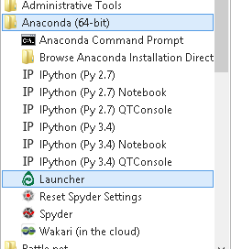

And then click “Luanch” to activate ipython notebook:

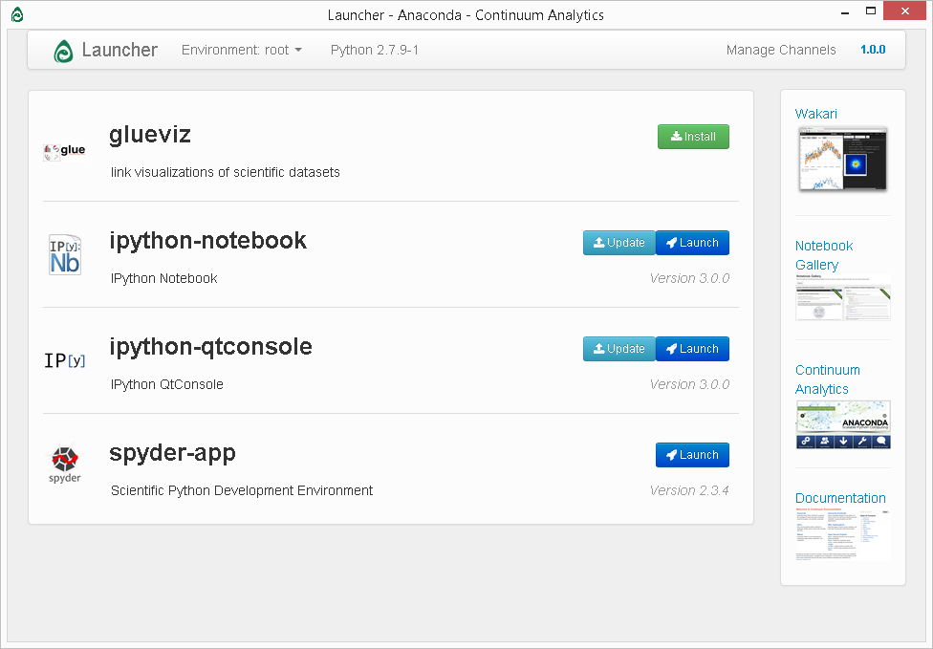

If there are updates available, you can click “Update” to patch new updates.